Accessibility Overview

CoMO are committed to making our website accessible for everyone. This document provides suggestions for modifications you can make in your operating system and browser to help access CoMO’s website. Please contact us if you require any support on accessing our website.
Contents
- Screen Readers
- Change text size
- Change mouse pointer visibility
- Change text and background colour
- Change Fonts

Screen readers

Our website is optimised for the following (most commonly used) screen readers:
- Windows + Firefox or Chrome: NVDA (Free reader)
- Mac + Safari: Voiceover (Built-in reader)
- Android + Chrome: Talkback (Built-in reader)
- iOS + Safari: Voiceover (Built-in reader)

Change text size

Google Chrome
- On your computer, open Chrome.
- At the top right, click More More and then Settings.
- Under 'Appearance', make the changes that you want:
- Change everything: Next to 'Page zoom', click the down arrow Down arrow. Then select the zoom option that you want.
- Change font size: Next to 'Font size', click the down arrow Down arrow. Then select the font size that you want. You can also change more font options by clicking Customise fonts.
Apple Safari
- To increase the font size, press Option-Command-Plus sign (+)
- To decrease the font size, press Option-Command-Minus sign (-)
Or you can go to the View menu and hold down the Option key while you select Make Text Bigger or Make Text Smaller.
Firefox
- Select the Menu button in the top-right of the Chrome web browser.
- Select Options from the menu.
- On the Firefox settings page, scroll down to the Language and Appearance section.
- Under Fonts and Colours, select the drop-down menu for Size and choose a new default size.
Microsoft Edge
- Open Microsoft Edge.
- Click the Settings and more (three-dotted) button from the top-right.
- Click on Appearance.
- Under the "Fonts" section, use the Font size drop-down menu and select a predefined option:
- Very small
- Small
- Medium
- Large
- Very large

Mouse pointer visibility

Windows 10
- Open Settings
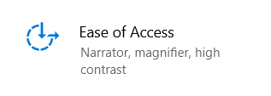
- Click on Ease of Access.
- Click on Cursor & pointer.
- Under the “Change pointer size and colour” section, use the slider to select a pointer size.
MAC OS
- Open System Preferences.
- Click on Accessibility.
- Click on Display.
- Look for the Cursor Size slider.
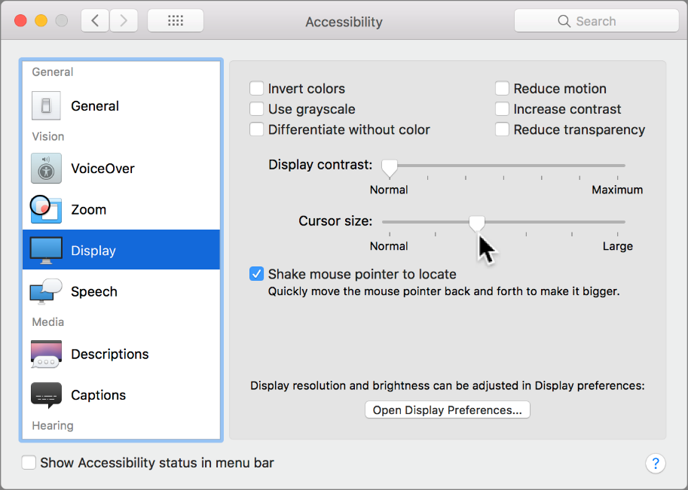
- As you drag the slider, your pointer changes size.

Change text and background colours

Microsoft Chrome
- Install an extension, such as the Care Your Eyes.
- Once installed, you will see the icon at end of URL field.
- Right-click on the icon and select Options to change background colour, text colour, links colour and visited links colour.
- Once your options have been set, you can click on the icon to apply/remove your colour options.
Apple Safari
- Select the Apple menu.
- Click System Preferences.
- Click Accessibility.
- Click Display.
- Click Colour Filters.
- Adjust display colours.
Firefox
- Click the menu button and select Options.
- In the General panel, go down to Language and Appearance.
- Under Fonts and Colours, click the Colours button.
- Clicking on any of the coloured rectangles will show you the possible colours you can choose from.
- Click OK.
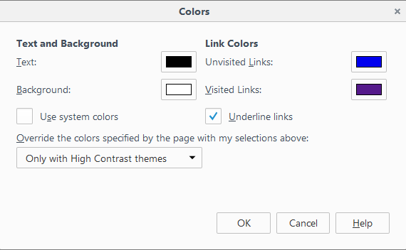
Microsoft Edge
- Select the tools icon in the top-right corner of the browser window.
- Select Internet options from the menu.
- In the Internet Options window, select the Accessibility button from the bottom-right corner.
- In the Accessibility window, select the checkbox labelled Ignore colours specified on webpages.
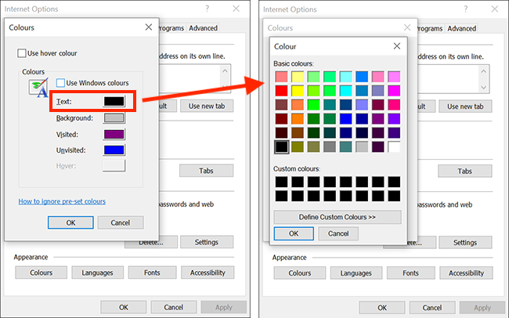
- You can now change the colour of the text, background and web links. Once done click OK to save your selections.

Change Fonts

Google Chrome
- Open Google Chrome.
- Click on the three vertical dots (the menu button) to the right of the URL bar.
- Select Settings.
- Scroll down and select Customize fonts under the Appearance heading.
- You can customize the font types here. Fonts in Google Chrome are split into four types: Serif, Sans-serif, Fixed-width, and Standard. Using the drop-down menus, you can select what specific fonts Chrome will use for each of these types.
- Select your font options, and then restart your browser to apply the changes.
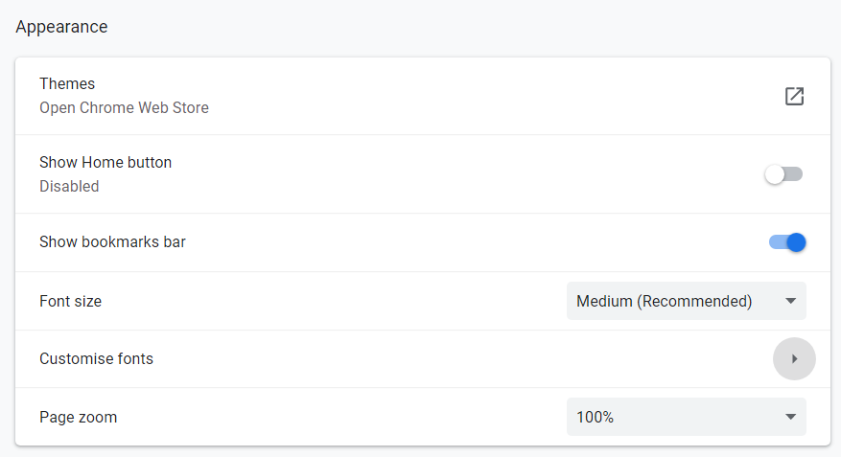

Apple Safari
- Select the Safari menu, then select Preferences.
- Select Appearance, which is the second option on the right.
- Under Standard font, select the Select button. Choose your desired font type, size and colour.
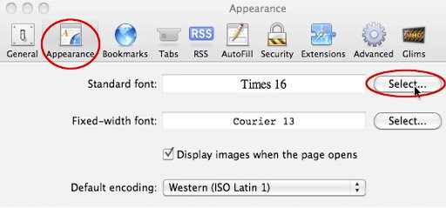
- Click OK on the Preferences screen.

Firefox
- Click the menu button and select Options.
- In the General panel, go down to Language and Appearance.
- Under Fonts and Colours, click the Fonts button.
- Select your preferred font.
- Click OK.
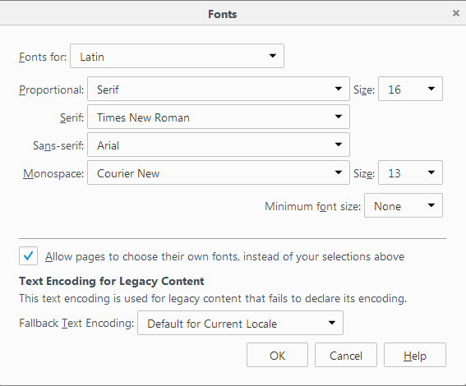
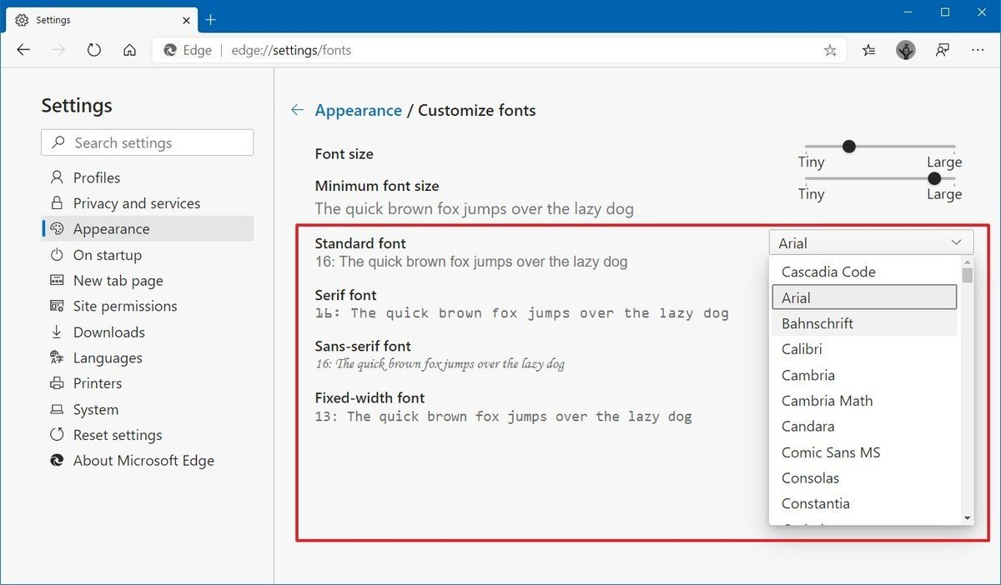
Microsoft Edge
- Open Microsoft Edge.
- Click the Settings and more (three-dotted) button from the top-right.
- Click on Appearance.
- Under the "Fonts" section, click the Customize fonts option.

